SEMESTER TWO
Papers written by Australian Maths Software

YEAR 11

MATHEMATICS APPLICATIONS
Units 1 & 2
2016
REVISION 3
Section Two
(Calculator–assumed)

Name: _________________________________

Teacher: ________________________________

TIME ALLOWED FOR THIS SECTION

Reading time before commencing work: 10 minutes
Working time for section: 100 minutes

MATERIAL REQUIRED / RECOMMENDED FOR THIS SECTION

To be provided by the candidate
Standard items: pens, pencils, pencil sharpener, highlighter, eraser, ruler.

Special items: drawing instruments, templates, notes on up to two unfolded sheets of A4 paper, and up to three calculators approved for use in examinations.

IMPORTANT NOTE TO CANDIDATES
No other items may be taken into the examination room. It is your responsibility to ensure that you do not have any unauthorised notes or other items of a non–personal nature in the examination room. If you have any unauthorised material with you, hand it to the supervisor before reading any further.

To be provided by the supervisor
Question/answer booklet for Section Two.
Formula sheet retained from Section One.
Structure of this examination

 | Number of questions available | Number of questions to be answered | Working time (minutes) | Marks available | Percentage of exam
Section One  Calculator—free | 6 | 6 | 50 | 52 | 35
Section Two  Calculator—assumed | 11 | 11 | 100 | 98 | 65
Total marks |  |  |  | 150

Instructions to candidates

1. The rules for the conduct of this examination are detailed in the Information Handbook. Sitting this examination implies that you agree to abide by these rules.

2. Write your answer in the Question/Answer booklet.

3. You must be careful to confine your responses to the specific questions asked and to
follow any instructions that are specific to a particular question.

4. Spare pages are provided at the end of this booklet. If you need to use them, indicate in the original answer space where the answer is continued i.e. give the page number.

5. Show all your working clearly. Your working should be in sufficient detail to allow your answers to be checked readily and for marks to be awarded for reasoning. Incorrect answers given without supporting reasoning cannot be allocated any marks. For any question or part question worth more than two marks, valid working or justification is required to receive full marks. If you repeat an answer to any question, ensure that you cancel the answer you do not wish to have marked.

6. It is recommended that you do not use pencil, except in diagrams.

7. The Formula Sheet is not to be handed in with your Question/Answer booklet.

Section Two: Calculator–assumed 100 marks

This section has eleven (11) questions. Attempt all questions.
Working time : 100 minutes

Question 7 (6 marks)

There are four teams in the football semi finals,the Piranhas, the Quokkas, the Rats and the Snakes. In this set of semi finals, each team plays each of the other three teams and the results are recorded below.
The Piranhas beat both the Quokkas and the Snakes. The Quokkas beat the Rats.
The Rats beat the Piranhas. The Snakes beat both the Quokkas and the Rats.
This information is shown in matrix  below
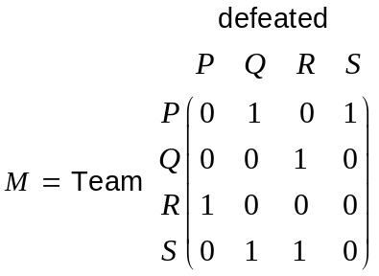
The ranking of the four teams can be calculated by obtaining the sum of each row of the matrix 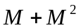 for the teams 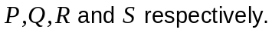
(a) Determine the matrix 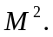 (2)

(b) Determine the matrix 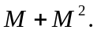 (2)

(c) Rank the teams by determining the sum of each row of for each of the four
teams. (2)

Question 8 (11 marks)

(a) Billy listed the weekly cost of running his Mitsubishi Lancer car

Interest | $19.35
On road costs | $36.35
Petrol | $28.79
Tyres | $3.50

(i) Determine the annual cost of petrol. (1)

(ii) Determine the total annual cost of running his car (2)

The RAC informed Billy that the rate of depreciation of his car was about $50 per week.
Billy had bought the car for $20 990.
(iii) What was the car worth at the end of one year? (1)

(iv) What rate of depreciation does that represent? (2)

(b) Holly found a dress at the dress shop but it was priced at $550. It did not sell. It was
reduced by 10% and it still did not sell. The shop then advertised a 20% discount on all its dresses. Holly bought the dress.

(i) How much did Holly pay for the dress? (2)

The shop had paid $380 for the dress.

(ii) Determine the percentage of profit or loss the
shop made on the dress. (3)

Question 9 (11 marks)

(a) (i) Use Heron’s formula to find the area of the triangle below. (2)

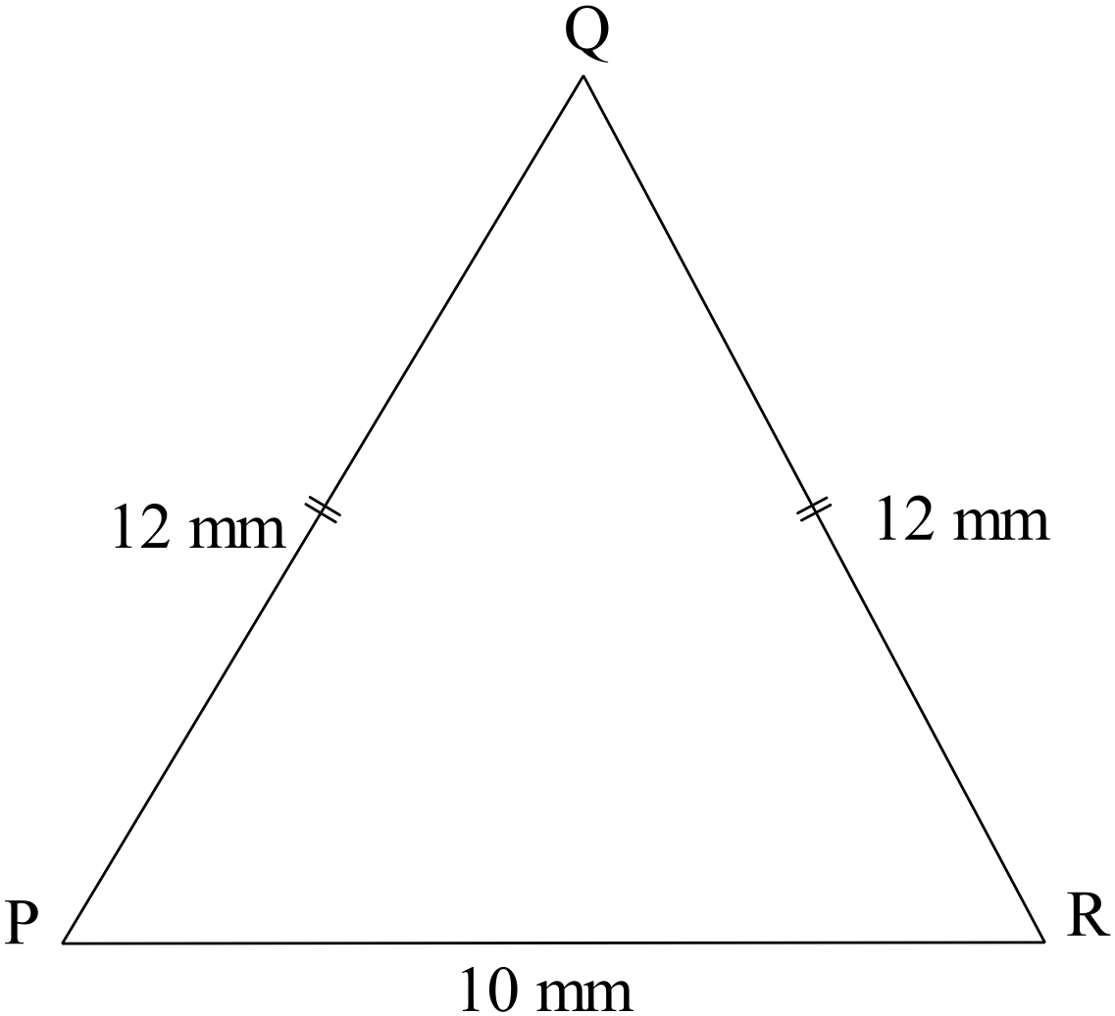

(ii) Find the size of the equal angles. (2)

(iii) Find the perimeter of the triangle ABC (3)

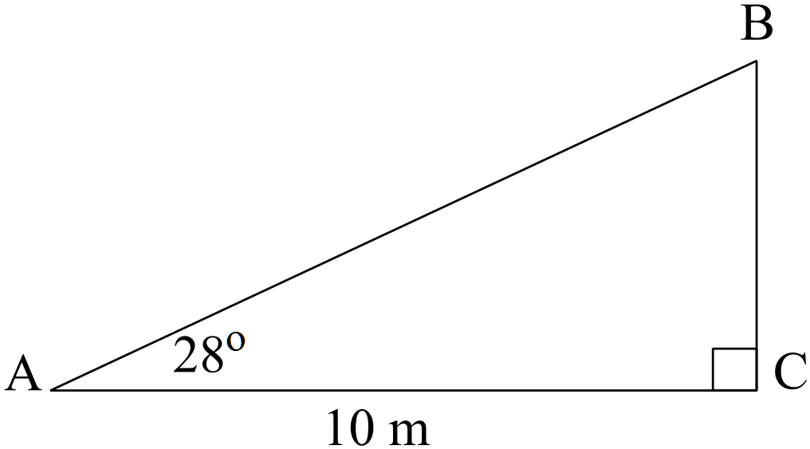

(b) The design of a fancy letter box is shown below.

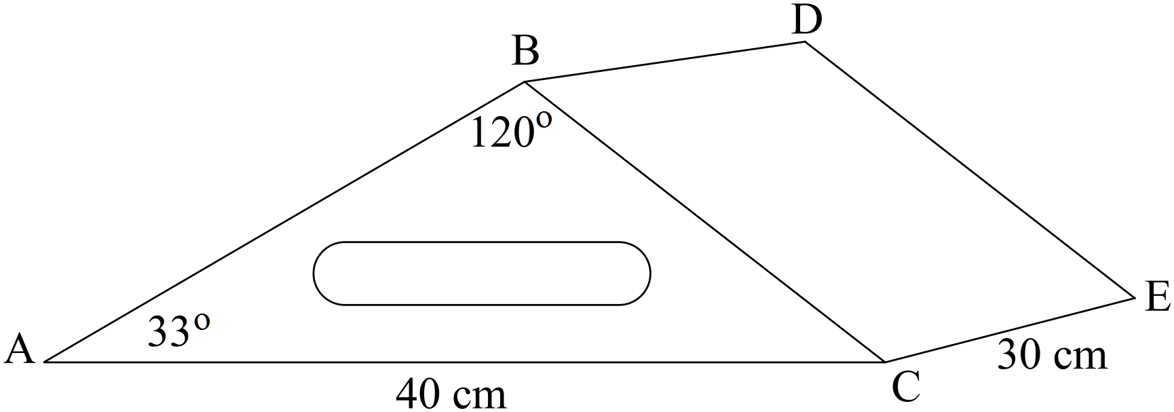

(i) Find the length of AB. (2)

(ii) Hence find the area of the triangle ABC. (1)

(iii) Find the volume of the letterbox. (1)

Question 10 (9 marks)

(a) Ben looked up at an aircraft at an angle of elevation of 38º. He was about to meet his
wife Pauline at the airport. He was exactly 5500 metres from home.

At exactly the same moment, Pauline on the plane, was looking down at their home (H)
at an angle of depression of 62º.

At that moment, the house, the plane and Ben are all in the same vertical plane.

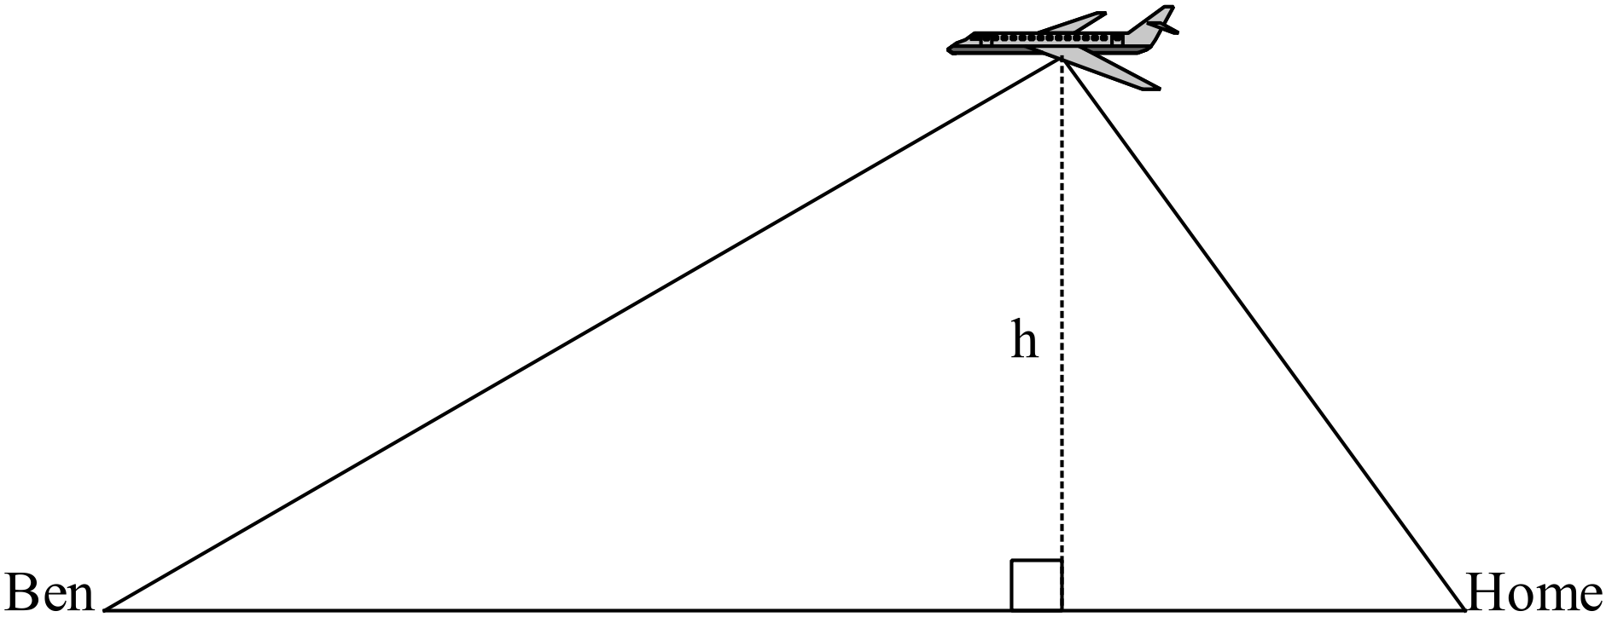

How high was the plane? (4)

(b) Another plane left Perth airport and flew 310 km at a bearing of 070º.
It then changed direction to 130º and flew 450 km before it landed.

(i) Sketch the path of the plane. (2)

(ii) Determine how far the plane is from Perth. (3)

Question 11 (5 marks)

(a) A new bench seat is planned for Elizabeth Quay. A model of the planned seat is made out
of the same construction material and is 6 cm high, 20 cm long and 3 cm wide. It weighs
0.007 kg.
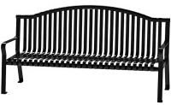
If the bench is to be 0.9 metre high, what weight of construction material is required for
the bench? (2)

(b) Bruce built a wooden rectangular gate that measures 0.9 m wide and is 1.8 m high. It was
not strong enough and Bruce decided to add a diagonal strut for strength.

What length of wood did Bruce need to buy for the strut given the strut needs to support 1.6 m height and 0.8m in width? (Allow an extra 4 cm) (3)
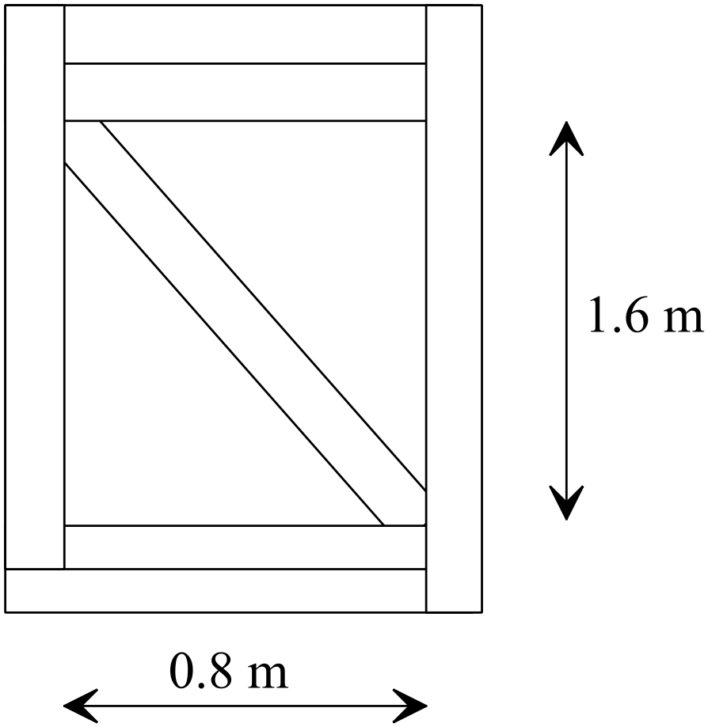

Question 12 (7 marks)

(a) What is the outside surface area of a cylindrical food container that is 8 cm high and has a radius of 12 cm? There is a lid at one end. Include the lid in the surface area. (4)

(b) Billy is meeting Joanne at the park. Billy jogs at 60 m/min and Joanne jogs at 50 m/min. If
they live 2.2 km apart, and jog towards each other in a straight line, how long is it before
they meet if they leave at the same time? (3)

Question 13 (8 marks)

A golf prize is shown with measurements below.

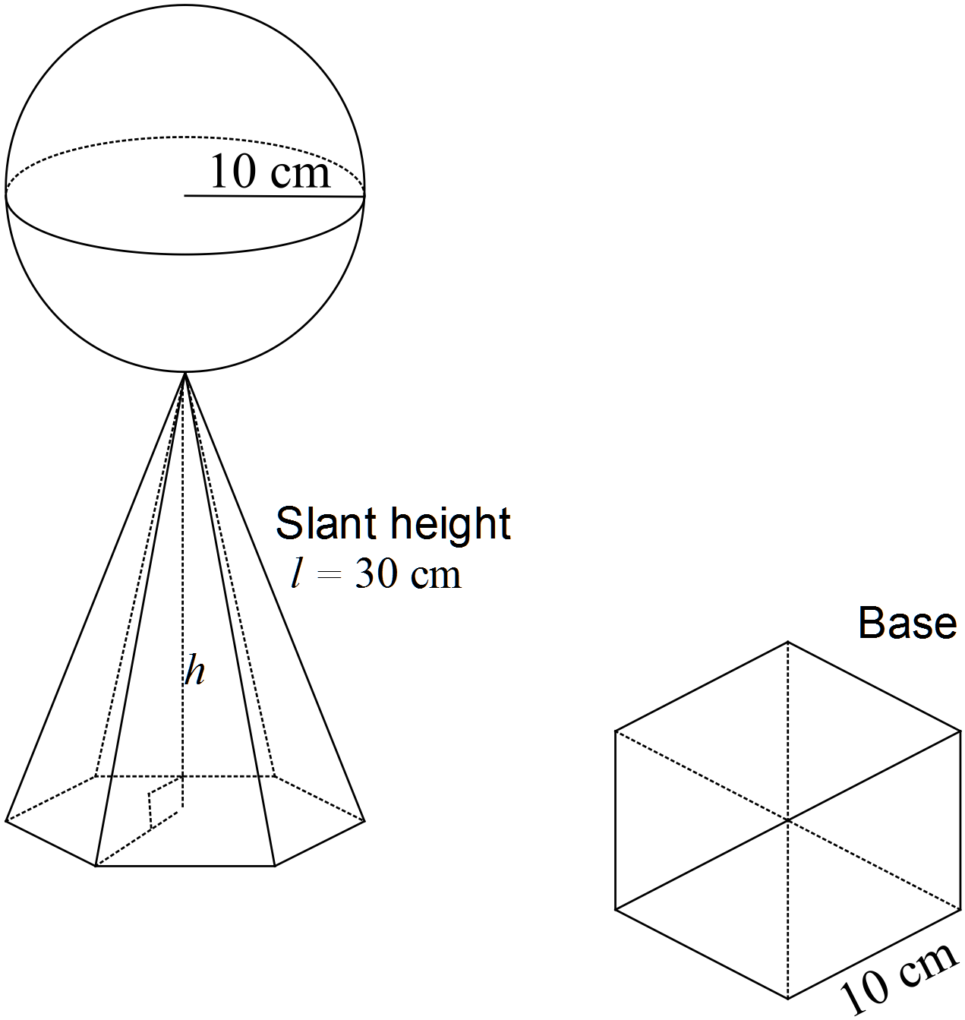
(a) Explain why 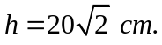 (2)

(b) Find the area of the hexagonal base. (3)

(c) Find the volume of the golf prize. (3)

Question 14 (4 marks)

Pam bought 2 dozen eggs and a loaf of bread for $10.30.
Casey bought 3 dozen eggs and 5 loaves of bread for $23.50.

Determine the price of one dozen eggs and a loaf of bread. (4)

Question 15 (13 marks)
(a) The scores of a Biology exam are normally distributed with 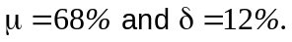
One of the Biology students is selected at random.
(i) Find the probability that the student got at least 50%. (2)

(ii) Find the probability that the student got less than 80%. (2)

(iii) Find the probability that the student got between 60% and 85%. (2)

(iv) What is the lowest mark the student could have got, if it was known he was in the
top 25%? (2)

(b) Tim is aware of the properties of the normal distribution and is a bit of a tease so he said to his friends
“ My Maths result is two standard deviations above the mean, but my English result equalled the mean.
I hate sport, so my PE score is awful. I was beaten by 97.5% of all the student doing PE in my year group.”

The mean for Maths was 70% and the standard deviation was 10.
The mean for English was 75% and the standard deviation was 15.
The mean for PE was 80% and the standard deviation was 15.

Determine Tim’s marks for his three subjects. (5)

Question 16 (17 marks)
(a) The box and whisker plot for the data 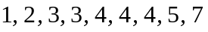 is show below.
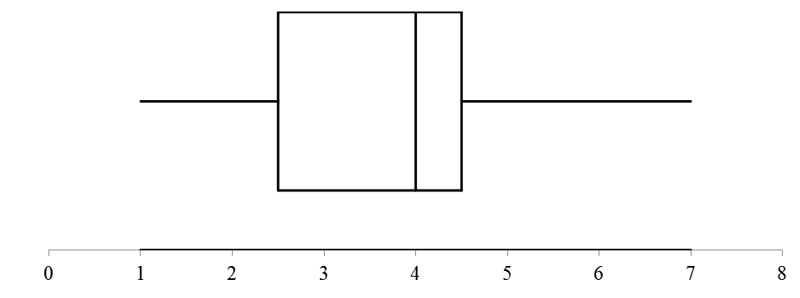
(i) Determine the range and interquartile range of the data. (3)

In answering the questions below refer to Q₁, Q₂, Q₃, IQR, the maximum or the minimum if this measure is affected.
(ii) By changing 7 to 10, how will this affect the original graph? (2)

(iii) By changing 2 to 3, how will this affect the original graph? (2)

(iv) By changing 4 to 3, how will this affect the original graph? (2)

(v) By adding 2 to each score, how will this affect the original graph? (2)

(vi) Compare and contrast the given box and whisker plot with the box and whisker plot
shown below. (4)

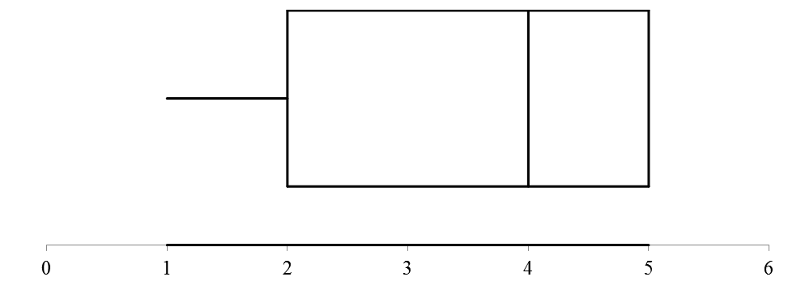

(b) Find p such that the mean of the scores p, 5, 5, 5 is 4,5. (2)

Question 17 (7 marks)

(a) Find the mean and the standard deviation of the following set of data. (3)

Score | Frequency
20 | 2
21 | 4
22 | 5
23 | 6
24 | 4
25 | 0
26 | 1

(b) Sketch two sets of symmetrical data 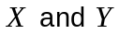such that
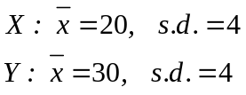 (4)

END OF SECTION TWO

